Convention 2022
On
Transformative Reform Interventions and Impact on Uttar Pradesh
(28 and 29 December 2022)

Schedule of Sessions and Profile of Speakers

Academic Partner

Lucknow Management Association
(Affiliated to All India Management Association)
"Smriti Bhawan", First floor, R-6/7, Vipul Khand
Gomti Nagar, Lucknow-226010
Telephone: 0522 4340519, 875 609 8128
Email: lmalucknow2016@gmail.com

Schedule of Sessions

Convention 2022
On
Transformative Reform Interventions and Impact on Uttar Pradesh
(28 and 29 December 2022)

Inaugural
28/12/2022
02.15 pm Log in by participants
02.30 pm to .02.35 pm About LMA and Vision & Mission by Mr. A.K. Mathur Vice President
02.35 pm to 02.40 pm Welcome address: Dr. Navneet Sehgal, IAS
Additional Chief Secretary Uttar Pradesh & President LMA
02.40 pm to 02.45 am Address by Academic Partner Prof. Kavita Pathak Director Jaipuria Institute of Management

02.45 pm Release of Convention Journal 2019 and remarks by Editor
02.45 to 02.55 pm Inaugural Address by Hon. Dy Chief Minister Sri Brajesh Pathak*
Vote of thanks: Mr. Pravin Dwivedi Sr. Vice President LMA
Session 1: Creating World Class Infrastructure and
28/12/2022
02.55 pm Introduction of speakers
02.55 pm to 03.20 pm Dr. Jaijit Bhattacharya President of Centre for Digital Economy Policy Research Theme: Rapid Infrastructure Rollout in UP.
03.20 pm to 03.45 pm Mr. Sudhendu J. Sinha Adviser (Infrastructure Connectivity – Transport and Electric3Mobility) NITI Aayog Theme: Gati Shakti – National Master Plan for Multi-modal Connectivity
Session 2: Creating Large Scale Employment through Manufacturing
3.45 pm Introduction of Speakers
3.45 pm to 4.05 pm Mr. Hindol SenGupta
Chief Economic officer Invest India
4.05 pm to 4.30 pm Mr. Sumit Peer
Director & CEO
Aurelius Corporate Solution Pvt Ltd
29 December 2022
Session 3: Making Ease of Living: the Purpose of Development
2.30 pm Introduction of Speakers
2.30 pm to 2.35 pm Introductory Remarks of Session Chair Mr. Alok Ranjan
Former Chief Secretary U.P. & Past President LMA
2.35 pm to 2.55 pm Mr. Parmeshwaran Iyer
CEO NITI Ayog,

2.55 pm to 3.20 pm Dr. R S Sharma
CEO, National Health Authority
MoHFW, Govt. of India
Closing Remarks by Session chair
*Confirmation awaited
Session 4: Leading Action on Climate Change and Environment
3.20 pm to 3.44 pm Mr. Sudhendu J. Sinha C
Adviser (Infrastructure Connectivity – Transport and Electric Mobility) NITI Aayog
3.40 pm to 4.00 pm Dr. Ajay Mathur
Chairman
International Solar Alliance Theme: UP as a Game Changer: Solar Energy, Electric Vehicle, and Water Management
Session 5: Capacity Building for Implementation of Development Agenda
4,00 pm to 4.20 pm Mr. S.D. Sharma
Jt. Secretary
Department of Personnel and Training
Govt. of India Theme: Mission Karm Yogi
4.20 pm to 4.40 pm Dr. Ashok Ganguly Former Chairman CBSC Theme: New Education Policy

Profile of Speakers

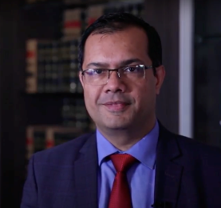
Dr. Jaijit Bhattacharya is a noted Digital Policy expert and author of six books, including the first book on e-governance in India, that was released by the then President of India, Dr. Abdul Kalam. He is currently President of Centre for Digital Economy Policy Research and Founder and CEO of Zerone Microsystems. He has over 60 peer reviewed papers to his credit that has been published in leading journals and conferences and has several patents and industry awards, including the prestigious Abdul Kalam Award for innovation in Governance. He has held senior leadership roles in leading technology and consulting companies and was last Senior Partner at KPMG. He has also been an Adjunct Professor at IIT Delhi for over a decade and has been on the senate of IIIT Raipur. Dr. Bhattacharya did his B.Tech from IIT Kanpur, MBA from IIM Calcutta and PhD in Computer Science from IIT Delhi.

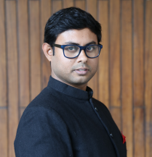
Dr. Hindol Sengupta is Chief Economic Research Officer at Invest India, the national investment promotion agency of the government of India under the Ministry of Commerce. He is an award-winning author of nine books published around the world. He won the Wilbur Award in 2018 for Being Hindu: Understanding a Peaceful Path in a Violent World, the first book on Hinduism to win the prestigious prize given by The Religion Communicators Council of America. Earlier winners of the award include writers like Christopher Hitchens and Mitch Albom. He won the PSF Prize for public service in India in 2015. Past winners of the prize include the late Indian scientist and President A. P. J. Abdul Kalam. His book Recasting India: How Entrepreneurship is Revolutionizing the World's Largest Democracy was short-listed in 2015 for the Hayek Prize given by the Manhattan Institute in memory of the Nobel laureate economist F. A. Hayek. In 2020, his book The Man Who Saved India: Sardar Patel and his idea of India was awarded the Valley of Words prize for Best Non-Fiction Book of the Year.
Sengupta is a World Economic Forum Young Global leader. He has been Senior Fellow for India’s best-known liberal think-tank, the Centre for Civil Society, and Senior Fellow at India’s biggest think-tank, the Observer Research Foundation.
He was educated in South Asian history and politics as a Chevening Scholar at Worcester College, Oxford, and in business and finance as a Knight-Bagehot Fellow at Columbia University. He has a doctorate in international relations from the Geneva School of Diplomacy and International Relations.

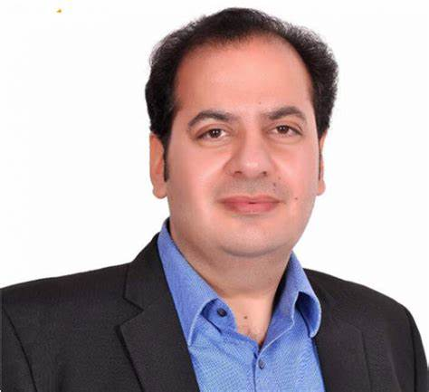
Mr. Sumit Peer is a Visionary Columnist, Entrepreneur, renowned Political Commentator, Speaker, globe-trotter and a concerned citizen with a mission of contributing towards nation building.
In his 23 plus years of experience with various multimillion-dollar, multicultural, multilingual organizations, Sumit lived & worked across three continents for over a decade and travelled to more than 60 countries for business.
As the fearless corporate leader, Sumit achieved enormous results and won many awards and accolades through his emphatic vision & execution globally. His vision to give back to the country led him to start some very innovative enterprises called Aurelius Corporate Solutions, United Perspectives. United Perspectives is a portal covering a host of subjects with a focus on national and global current affairs and enlightening people on sanatan way of life. www.unitedperspectives.com. He is today a renowned speaker, a thought leader and has addressed numerous national and international forums, conferences and seminars on various National Media TV Channels like News, Times Now, CNN News 18, India News, Republic, India AAJ TAK, IndiaAhead News, Amar Ujala TV, News 1 India, Sahara Samay, TV9 Bharatvarsh and so on. His critical and outspoken insights on matters of national interest, political developments, economy, technology, social issues are much appreciated. He is also widely called for interviews and discussions on Pakistani & Middle East Channels of AL Jazeera PTV (National TV Pakistan) Arzoo Kazmi, Qamar Cheema, Yousuf Fakharzai ,Arif Azakia etc for putting Indian perspective across. Have done more than 200 interviews so far concerning Socio economic and Geopolitical Issues.
He has also published path-breaking articles in over 50 news media like Economic Times, Business World, The Pioneer, Sunday Guardian The Outlook, Organizer, Business Standard, The Economist, CNN TV18, National UAE, IILFS, Beijing Post, Canada News, Manila Times and so on which has been received with utmost enthusiasm & respect. He is an active and regular columnist for Guardian. He is a tireless enthusiastic social worker and has been instrumental in upliftment of the underprivileged sections of the society as a concerned Indian having an allegiance to the welfare of the country at large.
He holds a Post-Graduation in Sales & Marketing, Advertising Management and General Management from the University of Cornell USA (Ivy League), besides having IT qualifications like MCSE, CCNA and CCDA. He comes from a Kashmiri Pandit family and had migrated to Delhi in the 1990 turmoil
Twitter Handle: sumitp191 (7K Plus) KOO Handle : @sumit_peercula (38 K Plus) PublicApp Handle @sumitpeer (670 K Plus followers and videos get views from a normal of 300k to Highest of 5 million)

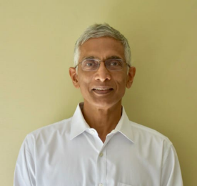
Mr Parameswaran Iyer is the Chief Executive Officer of NITI Aayog. He is a member of the Indian Administrative Service, Uttar Pradesh Cadre, 1981 batch. With an illustrious career spanning four decades, Mr Iyer has worked in various capacities with both the government and the World Bank.Between 2016–20, he served as the Secretary to the Government of India in the Ministry of Drinking Water and Sanitation in New Delhi and led the implementation of India’s flagship $20 billion Swachh Bharat Mission, which delivered access to safe sanitation to 550 million people.

A well-known water and sanitation expert, Mr Iyer has over 25 years of experience in the sector, having worked in several countries, including Vietnam, China, Egypt and Lebanon. In India, he headed the innovative community-led Swajal Project in Uttar Pradesh and Uttarakhand in the 1990s. The Swajal Project became one of the world’s leading rural water projects pioneering decentralized service delivery and key lessons were scaled up at the national level in India.

Mr Iyer did his Bachelor’s from St Stephen’s College, Delhi University and MBA from the National Management Programme, Management Development Institute, Gurgaon. Mr Iyer has authored two books: Method in the Madness: Insights from My Career as an Insider-Outsider-Insider (2021) and The Swachh Bharat Revolution: Four Pillars of India's Behavioural Transformation (2019).
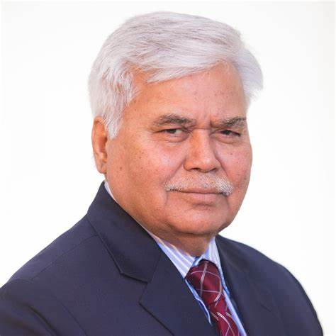
Dr. Ram Sewak Sharma is a bureaucrat and former civil servant. From February 2021, he is serving as the Chief Executive Officer of the National Health Authority, an Indian governmental organisation tasked with managing public health insurance. Previously, he has headed the Telecom Regulatory Authority of India, and the Unique Identification Authority of India. Born in a village of Uttar Pradesh, he completed his early education from schools near his village. He joined University of Allahabad from where he earned his Bachelor of Science (BSc). He completed his Masters in Mathematics from IIT, Kanpur, in 1978. While on leave from the Government of India, he earned a Masters in Computer Science from University of California, Riverside in 2002 and subsequently a PhD from IIT, Delhi.
He joined the Indian Administrative Service (IAS) in 1978.He belongs to the Jharkhand cadre. In 1986, he wrote a program in DBASE, a programming language that would keep a record of all stolen firearms in the crime-prone district. As soon as a firearm would be found, the programme would run a search query among thousands of age-old records. This software enabled the solving of 22 cases in just 30 days. He held responsibilities in his home cadre of Jharkhand as well as in ministries of the Central government, including, as Secretary, Department of Electronics and Information Technology and Chief Secretary of Jharkhand.
As the first Director General of the Unique Identification Authority of India, he helped create the 12-digit identity number, called Aadhaar, which is available to all eligible residents in India. He has authored a book titled The Making of Aadhaar: World's Largest Identity. Platform describing this project.
He was appointed the Chairman of Telecom Regulatory Authority of India (TRAI) from August 2015 for a period of three years. At the end of this tenure, he was given a further extension of two years.[As Chairman of TRAI, he steered the adoption of net neutrality regulations in India. He has taken measures to enable consumer choice in determining market outcomes, e.g. a new framework for broadcasting and cable services, regulations for mobile number portability, and the use of crowd-sourced information or field measurements to inform customers[ As the TRAI chairman, his goal to gradually reduce Interconnect Usage Charges earned him acclaim from some and criticism from others. Critics allege that the decision is biased towards Jio while those defending TRAI claim that reducing these charges was necessary for the continuous growth of the sector.
He is the chairperson of an empowered committee for administration of Covid-19 vaccine delivery technology platform (Co-WIN). CoWIN along with the national Covid-19 vaccination campaign was launched by the Prime Minister on January 16, 2021. Dr. Sharma was called back from retirement to take the responsibility of developing and executing the CoWIN or the Covid-19 Vaccine Intelligence Network. India crossed a mark of administering 2 billion vaccinations in July, 2022. The country also signed an MoU with the government of the Co-operative Republic of Guyana for sharing CoWIN.
Dr. Sharma also served on the National Expert Group on Vaccine Administration for COVID-19, a body constituted by the Government of India to tackle the Covid-19 pandemic in India.
In February 2021, Dr.Sharma was appointed as the Chief Executive Officer of the National Health Authority of India, a body responsible for implementing two health initiatives of the Government of India, Ayushman Bharat Jan Arogya Yojana (AB PM-JAY) which is a public health insurance scheme and Ayushman Bharat Digital Mission, a platform to promote digitization of healthcare in India .
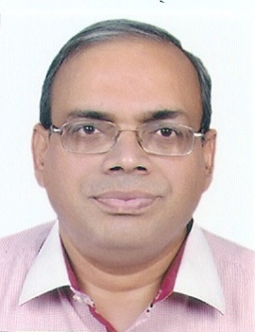
Mr. Sudhendu J. Sinha
An alumnus of St. Stephen's College, Delhi did his Major in History. He has experience of over 29 years in operations, infrastructure planning, coordination and management at field and policy making levels in Indian Railways with considerable success and appreciation. His performance has been recognised and awarded twice at the National level (National Award for e-Governance- 2019-20, for ‘Excellence in providing Citizen - Centric Delivery’ by Department of Administrative Reforms and Public Grievances, Govt. of India, ‘National Award for Outstanding Service’ Ministry of Railways Govt. of India -2006) and thrice at the Ministry (of Railways) level. He also served as Dean of the Indian Railway Institute of Transport Management (IRITM), Lucknow, and General Manager Web Applications at the Centre for Railway Information Systems (CRIS). He has training and enrichment from Japan (Railway Management), Malaysia (ICLIF - Advance Management), Singapore (INSEAD - Advance Management), Germany (UIC) and the US (Oracle).

He is the Adviser at the NITI Aayog (National Institution for Transformation of India), the

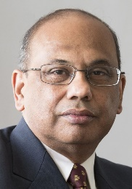

Dr. Ajay Mathur

Director General The International Solar Alliance

Dr Ajay Mathur heads The International Solar Alliance, leads its operations and as Director General, carries out the functions of the ISA Secretariat and is responsible to the ISA Assembly. Prior to joining ISA, Dr. Mathur was Director General of The Energy and Resources Institute (TERI). At TERI, he has spearheaded the move to accelerate action towards a low-carbon and cleaner economy through the promotion and adoption of renewable energy and green hydrogen in the Indian electricity sector, enhancing efficiency in buildings and industry, and promoting environmental quality through institutional and policy measures to enhance air quality across the country, adoption of resource efficiency and waste recycling measures, and biotechnology-based solutions, especially for agricultural and industrial environment improvement. He also anchored the annual World Sustainable Development Summits during his tenure at TERI. He was also member of Indian Prime Minister’s Council on Climate Change and co-chair of the global Energy Transitions Commission and of the Clean Cooling Initiatives of the One Planet Summit. He earlier headed the Indian Bureau of Energy Efficiency and was responsible for its foundational programmes which mainstreamed energy efficiency through initiatives such as the Star Labeling programme for appliances, the Energy Conservation Building Code, and the Perform, Achieve & Trade programme for energy-intensive industries. He was a leading climate change negotiator and was the Indian spokesperson at the Paris climate negotiations. He served as the interim Director of the Green Climate Fund during its foundational period.

Dr. Mathur received a bachelor’s degree in Chemical Engineering from the (then) University of Roorkee, and Masters and PhD degrees from the University of Illinois. He has also received the Distinguished Alumnus Awards from both his alma maters. He was appointed a Chevalier de l’Ordre national du Merite by the President of France in recognition of his outstanding commitment to the preservation of the environment and coping with energy-related challenges.

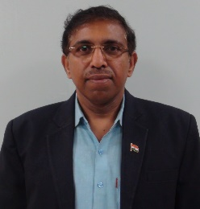
Shri S.D. Sharma is Joint Secretary, DoPT handling the additional charge of the post of Director, Institute of Secretariat Training and Management. He holds a Master’s degree in Commerce from Department of Commerce, Delhi School of Economics, University of Delhi. He is a Fellow Member of Institute of Cosmaster’stants of India. In addition, he holds a master’s degree in Public Policy and Sustainable Development from TERI School of Advanced Studies and a master’s degree in Finance from Pondicherry University.

He has worked in several Ministries / Departments / Organizations such as Ministry of Defence, Ministry of Shipping, National Highway Authority of India, Ministry of Home Affairs, Cabinet Secretariat and Department for Promotion of Industry and Internal Trade (DPIIT).

Objectives and

